Lecture 2: Query Tuning

2.1 Methods

- Eliminating redundant DISTINCT
- Rewriting nested queries

2.2 Relational Algebra

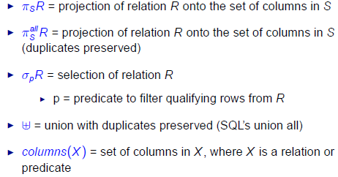

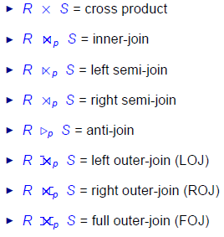
2.2 Functional Dependencies
- Functional Dependencies (FDs) are constraints on schemas that specify that the values for a certain set of attributes determine unique values for another set of attributes
- Let a and b denotes subsets of attributes of a relational schema R (i.e. a, b [ columns ( R )]
- We use a → b to denote that a functionally determines b (or B functionally depends on a)
- Let πα(t) denote the projection of α on tuple t
- Let r be a relation instance of relation schema R
- r satisfies FD α → β if for every pair of tuples t1 and t2 in r such that πα(t1) = πα(t2), it is also true that πβ(t1) = πβ(t2)
- A FD α → β holds on R iff for any relation instance r of R, r satisfies α → β

- A set of attributes α is a superkey of schema R if for every instance r of R, r has no duplicate values for α
- α is a superkey of R iff α → columns(R)

- α is a key of R if α is a superkey of R and no proper subset of α is a superkey of R

Review: Reasoning about FDs
- Let F be a set of FDs and f be an FD
- F logically implies (or implies) f if every relation instance of R that satisfies the FDs F also satisfies the FD f

Inference Rules for FDs
- Let α, β, γ subset of columns(R)
  - Reflexivity: If β subset of α, then α → β
  - Augmentation: If α → β, then αγ → βγ
  - Transitivity: If α → β and β → γ, then α → γ
  - Union: If α → β and α → γ, then α → βγ
  - Decomposition: If α → β, then α → β′ for any β′ subset β

- Let α be the subsets of columns(R)

- Let F be a set of FDs that hold on R

- The closure of α (with respect to F), denoted by α+, is the set of attributes that are functionally determined by α with respect to F
  - α+ = {A subset of columns(R) | F implies α → A}
  - paraphrase, given 1 set of columns α, what columns can this α determine

- F implies α → β if and only if β subset of α+ (w.r.t. F)

Input: α, F
Output: α+ (w.r.t. F)
α+ = α
stop = false
repeat
if (there exists some FD β → γ ∈ F such that β ⊆ α+ and γ 6∈ α+) then
α+ = α+ ∪ γ
else
stop = true
until (stop)
return α+
2.3 Eliminating Redundant Distinct

- SPJ (Select Project and Join) Queries

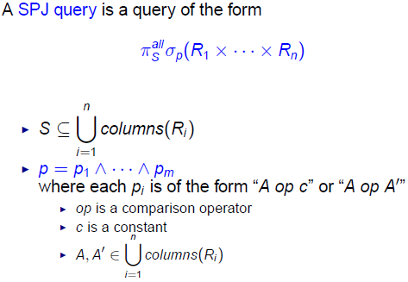
Lecture 3: Query Tuning (Part 2)

3.1 Reordering Group by & Select

- Customer (cust#, cname, country)
- Order (order#, cust#, date, totalprice)

  - select cust # , date , t o t a l
from (
select cust # , date , sum( t o t a l p r i c e ) as t o t a l
from Order
group by cust # , date
)
where date >= '2013−01−01 '

  - select cust # , date , sum( t o t a l p r i c e ) as t o t a l
from Order
where date >= '2013−01−01 '
group by cust # , date

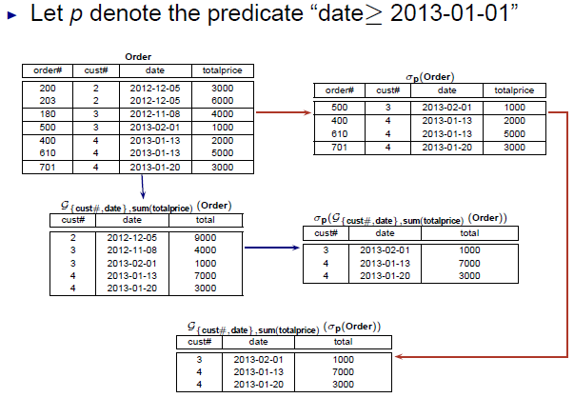

It is possible to reorder group by as follow:

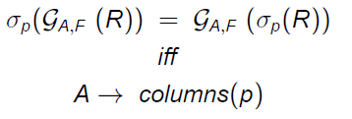
3.2 Pushing Group By Below Join

- Customer (cust#, cname, country)
- Order (order#, cust#, date, totalprice)

  - select c . cust # , cname , sum( o . t o t a l p r i c e ) as T
from Customer c join Order o
on c . cust# = o . cust#
group by c . cust # , cname

  - select c . cust # , cname , T
from customer c ,
(
select cust # , sum( t o t a l p r i c e ) as T
from Order
group by cust#
) as o
where c . cust# = o . cust#

- Example 1:

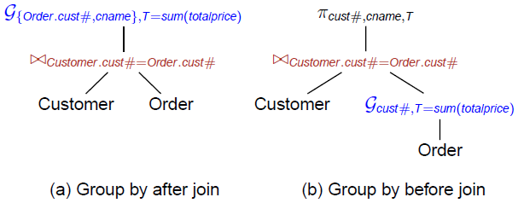

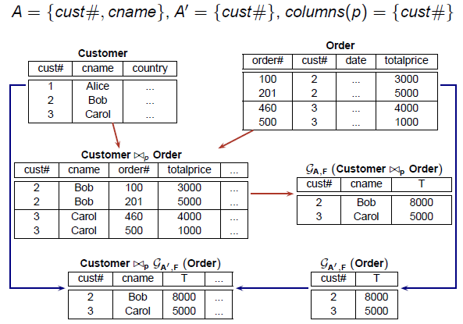
- Example 2

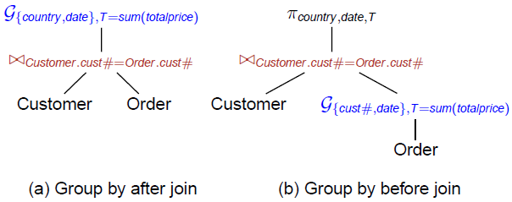

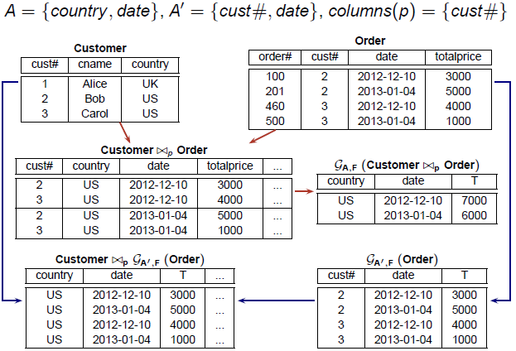

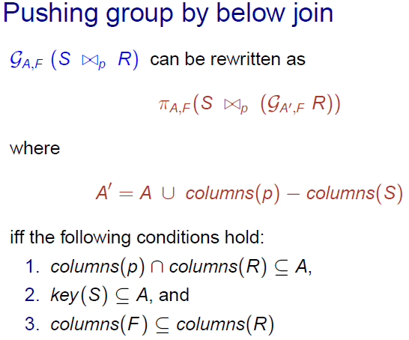
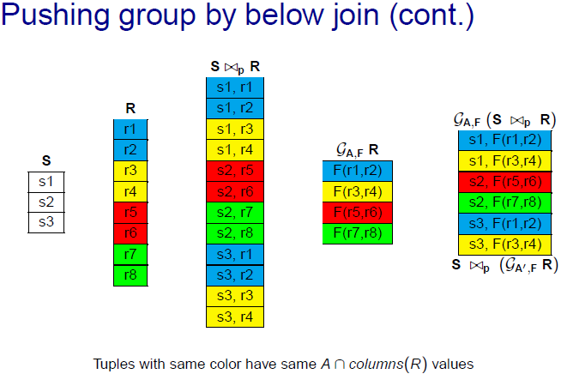

- Rewriting Example 1:

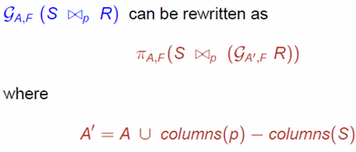

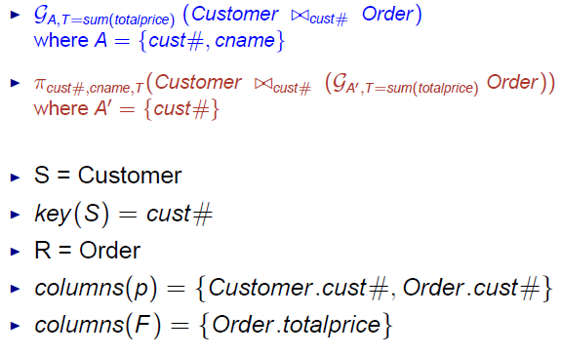
- Rewriting Example 2:

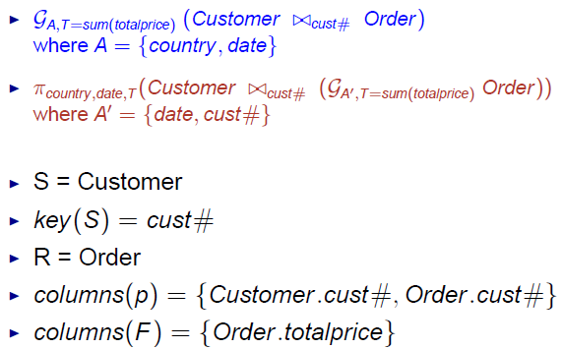

3.3 Pulling group by above join

- Customer (cust#, cname, country)
- Order (order#, cust#, date, totalprice)

  - select c . cust # , cname , count ry , date , T
from customer c ,
( select cust # , date , sum( t o t a l p r i c e ) as T
from Order
group by cust # , date
) as o
where c . cust# = o . cust#

  - select c . cust # , cname , country , date ,
sum( o . t o t a l p r i c e ) as T
from Customer c join Order o
on c . cust# = o . cust#
group by c . cust # , cname , country , date

- Example 3:

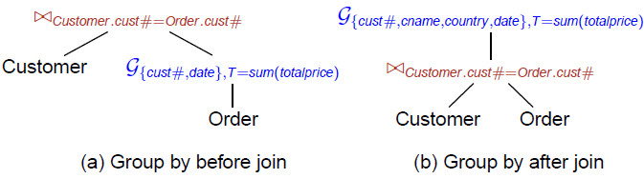

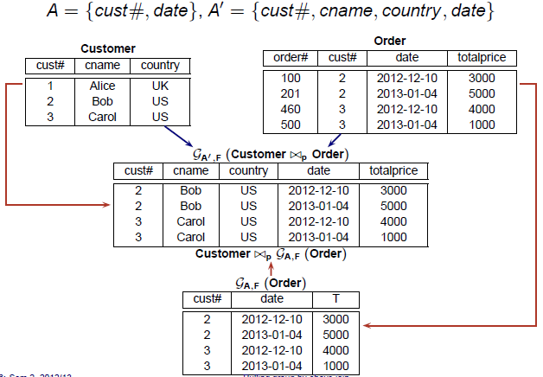

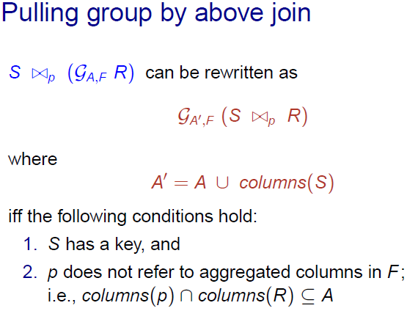
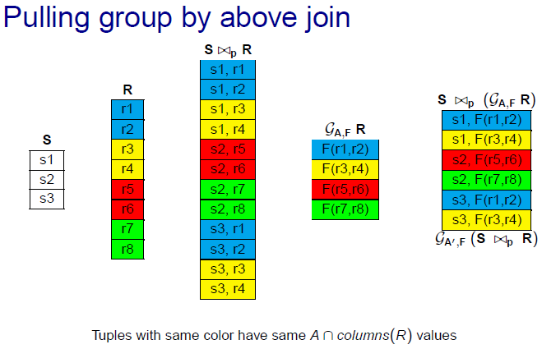

Lecture 5: Materialized View

5.1 Concept
- Given a view V and a query Q, V subsumes Q if
  - V contains at least all the tuples required in Q, and
  - it is possible to filter out the irrevalent tuples from V
- If a view V subsumes a query Q, then V can be used to answer Q

select S1, S2, · · · – projection columns
from T1, T2, · · · – tables
where J1 and J2 and · · · – equi-join predicates
R1 and R2 and · · · – range predicates
Z1 and Z2 and · · · – residual predicates
group by G1, G2, · · · – grouping columns

- Each range predicate is a disjunction of open/closed intervals over same column
- Example:

- Materialized view denoted by V = (S, T, J, R, Z,G)
  - S = set of columns in the select clause
  - T = set of tables
  - J = set of join predicates
  - R = set of range predicates
  - Z = set of residual predicates (A residual predicate is one that has an hidden extra cost because the predicate has to be tested again on every combination of rows that is fetched.)
  - G = set of grouping columns

5.2 Predicate Containment
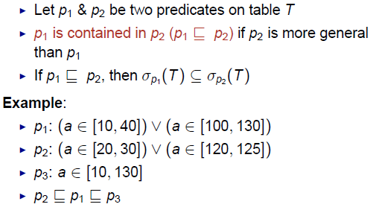

5.3 View matching algorithm
- Let Q be a query & V be a view
- If V & Q are in L_{MV} , there exists simple & sufficient conditions to check if a V subsumes Q
- V matches Q if these sufficient conditions are satisfied
- V matches Q => V subsumes Q
- To check if V’s predicates match Q’s predicates:
  - join predicates in Q ⊇ join predicates in V
  - residual predicates in Q ⊇ residual predicate in V
  - for each range predicate column C: Q’s predicate on C ⊑ V’s predicate on C
5.4 Materialized View Transformation
- Merging: merges two views into a single view
  - View merging: V1 ⊕ V2
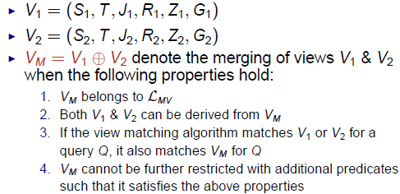

- Reduction: reduces a view into another view involving fewer tables

  - View reduction: _(V)

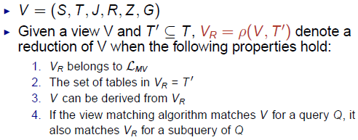

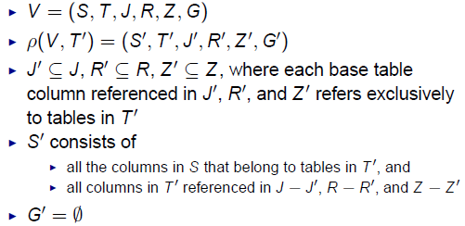

  - Invalid View Reduction
    - A view reduction _(V, T′) is invalid if it contains some cartesian product and V does not contain any cartesian product

5.5 Indexes over Materialized View

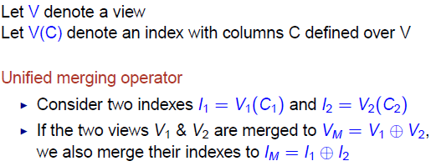

5.6 Unified merging operator

Lecture 6: Transaction Tuning (Chopping)

6.1 Read/Write From & Final Write
- We say that T_{j} reads O from T_{i} in a schedule S if the last write action on O before R_{j}(O) in S is W_{i}(O)
- We say that Ti performs the final write on O in a schedule S if the last write action on O in S is Wi(O)
- Example
  - R1(A),W1(A),R2(A),W2(A),R1(B), W1(B),Commit1,R2(B),W2(B),Commit2
    - T2 reads A from T1
    - T2 reads B from T1
    - T2 performs the final write on A
    - T2 performs the final write on B

6.2 Anomalies with interleaved Execution
- Two actions on the same object conflict if
  - (1) at leaset one of them is a write action
  - (2) the actions are from different Xacts

- Anomalies can arise due to conflicting actions:
  - Dirty Read Problem (due to WR conflicts)
    - T2 reads an object that has been modified by T1 (which has not yet committed)
    - T2 could see an inconsistent DB state
  - Unrepeatable read problem (due to RW)
    - T2 updates an object that T1 has just read while T1 is still progress
    - T1 could get a different value if it reads the object again
  - Lost update problem (due to WW conflicts)
    - T2 overwrites the value of an object that has been modified by T1 while T1 is still in progress.
    - T1 update is lost.

6.3 Conflict Serializable Schedule
- Two schedule S and S1 are said to be conflict equipvalent if
  - (1) they involve the same set of actions of the same Xaxts
  - (2) They order every pair of conflicting actions of 2 committed Xacts in the same way
- A schedule is a conflict serializable schedule if it is conflict equivalent to a serial schedule

6.4 Testing for conflict Serializability
- A conflict serializability graph for a schedule S is a directed graph G = (V,E) such that
  - V contains a node for each commited Xact in S
  - E contains (T_{i}, T_{j}) if an action in Ti tes and conflicts with one of Tj’s actions
- Theorem: A schedule is conflict serializable iff its conflict serialiability graph is acyclic

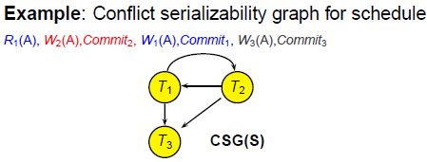
- Transaction Scheduler
  - For each input action (read,write,commit,rollback) to the scheduler, the scheduler performs one of the following:
    - Output the action to the schedule
    - Reject the action and abort the transaction, or
    - Postpone the action by blocking the transaction

6.5 Lock-Based Concurrency Control

- Each Xact needs to request for an appropriate lock on an object before the Xact can access the object
- Locking modes
  - Shared (S) locks for reading objects
  - Exclusive (X) locks for writing objects
- A Xact is blocked if its request for a lock on an object is incompatible with an existing lock on the object held by some other Xact
- Notations:
  - S_{i}(O): Xact T_{i} is requesting S-Lock on object O
  - X_{i}(O): Xact T_{i} is requesting X-Lock on object O
  - U_{i}(O): Xact T_{i} releases lock on object O
- Example
  - R1(A), W2(A), W2(B), W1(B)
  - S1(A),R1(A),U1(A),X2(A), W2(A), X2(B), W2(B), U2(A),U2(B),X1(B), W1(B), U1(B)

6.6 Two Phase Locking (2PL) Protocol
- 2PL Protocol
  - To read an object O, a Xact must hold a S-Lock or X-Lock on O
  - To write an object O, a Xact must hold a X-Lock on O
  - Once a Xact releases a lock, the Xact cannot request more locks (regardless of shared or exclusive lock)
- Xacts using 2PL can be characterized into two phases
  - Growing phase: before releasing 1st lock
  - Shrinking phase: after releasing 1st lock
- Theorem: 2PL schedules are conflict serializable
- STRICT 2PL Protocol
  - To read an object O, a Xact must hold a S-Lock or X-Lock on O
  - To write an object O, a Xact must hold a X-Lock on O
  - A Xact must hold on to locks until Xact commits or aborts
- Dead Lock
  - Cycle of Xacts waiting for locks to be released by each other
  - Example:
    - T₁ requests X-Lock on A and is granted;
    - T₂ requests X-Lock on B and is granted;
    - T₁ requests X-Lock on B and is blocked;
    - T₂ requests X-Lock on A and is blocked;

6.7 Phantom Read Phenomenon

- A transaction re-executes a query returning a set of rows that satisfy a search condition and finds tha the set of rows satisfying the condition has changed due to another recently committed transaction
- Can be prevented by predicate locking via index locking

6.8 Transaction Chopping

- Introduction
  - A chopping partitions T into k pieces, k>=1
  - Each database access performed by T is in exactly one peience
- Why Chopping
  - Chopping can increase concurrency
- CSG (S,T)
  - Let T denote a set of transactions
  - Let T¹ denote a chopping of T
  - Let S denote a schedule for T¹
  - We use CSG(S, T¹) to denote the conflict serializability graph for schedule S wrt the set of transactions T¹
  - If S is a S2PL schedule for T^{1,} then
    - CSG(S, T¹⁾ must be acyclic
    - But CSG(S,T) could be cyclic
- Rollback-Safe Chopping
  - A chopping of T is rollback-safe if
    - Either T has no rollback statements
    - Or all rollback statements of T are in its first piece
  - All the statements in the first piece must execute before any other statement of T
  - A chopping of a set of transactions is rollback-safe if the chopping of each its transaction is rollback-safe
  - Execution rules
    - Each piece acts like a transaction: follows strict 2PL protocol
    - Order of execution of pieces follow order of transaction
    - If a piece is aborted because of a lock conflict, then it will be resubmitted repeatedly unil it commits’
    - If a piece is aborted because of a rollback, then no other pieces for that transaction will execute
  - Correct Chopping
    - A chopping of {T₁,…,T_{n}} is correct if any execution of the chopping that obeys the execution rules is conflict equipvalent to some serial execution of the original transactions.
  - Conflicting Pieces
    - Two pieces P and P¹ are conflicting if all the following conditions hold:
      - P and P¹ belong to different transactions,
      - P contains a step that writes an object O, and
      - P¹ contains a step that reads/writes the same object O
  - Chopping Graph
    - Undirected graph
    - Each vertex represents a chopped piece
    - Two types of edges
      - Conflict edges (C-edges)
      - Siblings edges (S-edges)
    - (P and P¹) is a S-edge if a P and P¹ belong to the same transation
    - P and P¹ is a C-edge if P and P¹ is a pair of conflicting piece
  - Graph Concepts
    - A simple cycle consists of a sequence of distinct nodes < V₁, V₂ …., V_{n} such that
      - There us an edge (V_{i}, V_{i+1}) for each I subset [1,n] and
      - There an edge (V_{n}, V₁)
    - A connected component C in a graph G is a maximal subgraph of G such that for every pair of nodes V & V¹ in C, v i connected to V¹ by some path
  - SC-Cycle
    - A chopping graph has a SC-cycle if it contains a simple cycle that includes at least one S-edge at least one C-edge
  - Correct Chopping
    - Theorem1: A chopping is correct if
      - It is rollback-safe, and
      - Its chopping graph contains no SC-cycle
    - Lemma 1:
      - If a chopping graph contains and SC – Cyle, then any further chopping of any of the transactions will not render it acyclic
    - Lemma 2:
      - If two pieces of transaction T are in an SC-cycle as the result of some chopping, then they will be a cycle even ig no other transactions are chopped
  - Private chopping
    - Consider a set of transactions T = {T₁,…. T_{n}} that run at an interval
    - Let chop(T_{i} ) denote a chopping of T_{i}
    - chop(T_{i} ) is a private chopping of T_{i,} denoted by private(T_{i} ), if
      - chop(T_{i} ) is a rollbacl-safe chopping of Ti and
      - there is no SC-cycle in the graph whose nodes are (T − {Ti}) ∪ chop(Ti)

    - Theorem2:
      - The chopping consisting of {private(T1), … , private(Tn)} is rollback safe and has no SC-cycles.
  - Finest Chopping
    - Let FineChop(T_{i}) denote the finest chopping of Ti with the following two properties
      - FineChop(T_{i}) is a private chopping of T_{i}
      - If piece p is a member of FineChop(T_{i}) then there is no other private chopping of To containing P₁ and P₂ such that P₁ and P₂ partition p and neither is empty
Lecture 7: Transaction Tuning 2 (Snapshot Isolation)

7.1 Multiversion Concurrency Control (MVCC)
- Motivation : Increase concurrency
- Key Idea: maintain multiple versions of each object
- W (O) creates a new version of object O
- R (O) reads the most recent version of O that is created by a committed Xact
- Advantages
- Readers are not blocked by writers
- Readers do not block writers
- Read-only Xacts are never aborted
- MVCC Techniques
- Multiversion 2phase locking
- Multiversion timestamp ordering
- Snapshot isolation

7.2 Snapshot Isolation
- Widely used by (e.g. Oracle, SQL server etc)
- Each Xact T sees a snapshot of the DB that consists of updates by Xacts that committed before T starts
- Each Xact T is associated with 2 timestamps
- Start(T): the time that T starts
- Commit(T): the time that T commits
- 2 Xact are defined to be concurrent if their start/commit time overlaps each other
- Example
- Wi(O) creates a version of O denoted by Oi
- Ri(O) reads the latest version of O that is created by a Xact that committed before Ti started;
i.e., If Ri(O) returns Oj , then
1. commit(T_{j}) < start(T_{i}), and
2. For every Xact T_{k} , k 6= j, that has created a version Ok of
O, if commit(T_{k} ) < start(T_{i}), then commit(T_{k} ) < commit(T_{j})
Note: if T_{i} has updated O, then any R_{i}(O) following Wi(O) will read O_{i}
- Tradeoff
- Performance often similat ro read committed
- Does not suffer from lost update or unrepeatable read anomalies
- But vulnerable to some non-serializable execution
  - Write skew anomaly
  - Read-Only Transaction Anomaly

7.3 First Committer Wins Rule
- If two concurrent Xacts update the same object, only one of them can commit
- First Committer Wins (FCW) Rule:
  - Before commiting a Xact T, the system checks if there exists a committed concurrent Xact T′ that has updated some object that T intends to update
  - If T¹ exists, then T aborts
  - Otherwise, T commits with its updates written to the database

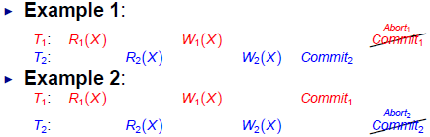
7.4 First Updater Wins Rule
- Some implementations use write locks to prevent concurrent updates to same objects
- FCW rule becomes First Updater Wins (FUW) Rule
- First Updater Wins Rule:
  - Before a Xact T can update an object O, T needs to request for a write lock on O
  - If another Xact is holding a write lock on O, T is blocked
  - When T’s lock request on O is granted, the system checks if some other committed concurrent Xact has updated O
  - If so, T aborts
  - Otherwise, T updates O and proceeds with its execution

7.5 Transactional Dependencies
- ww dependency from T1 to T2
  - T1 writes a version of some data item x, and
  - T2 later writes the immediate successor version of x
- wr dependency from T1 to T2
  - T1 writes a version of some data item x, and
  - T2 reads this version of x
- rw dependency from T1 to T2
  - T1 reads a version or some data item x, and
  - T2 later creates the immediate successor version of x

The above definitions assume data item reads/writes & can be generalized for predicate reads/writes

7.6 Dependency Serialization Graph
- Consider a schedule S consisting of a set of committed transactions {T1, · · · , Tk}
- DSG(S) is an edge-labelled directed graph (V, E)
- V represents transactions {T1, · · · , Tk}
- E represents transactional dependencies
  - Ti (ww)→ Tj
  - Ti (wr) → Tj
  - Ti (rw) →Tj
- Edge types:
  - if transaction pair is concurrent
  - if transaction pair is non-concurrent
- Example
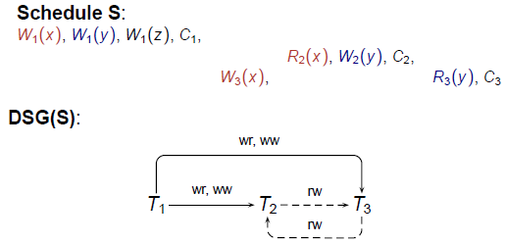

7.7 Non-Serializable SI Schedules
- Theorem 1: If S is a non-serializable SI schedule, then
  - 1. There is at least one cycle in DSG(S), and
  - 2. For each cycle in DSG(S), there exists three transactions, T_{in}, T_{pivot} , and T_{out} such that
    - T_{in} & T_{out} are possibly the same transaction,
    - T_{in} & T_{pivot} are concurrent with an edge T_{in} (rw) →T_{pivot} , and
    - T_{pivot} & T_{out} are concurrent with an edge T_{pivot} (rw) → T_{out} .

First Example is Skew Anomaly, Second is a Read-only Xact anomaly
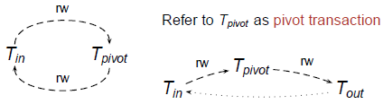
- Theorem 2: If an application A has a static dependency graph SDG(A) with no dangerous structure, then A is serializable under SI

7.8 Static Dependency

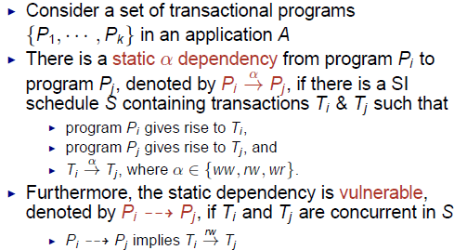

Static Dependency Graph (SDG)

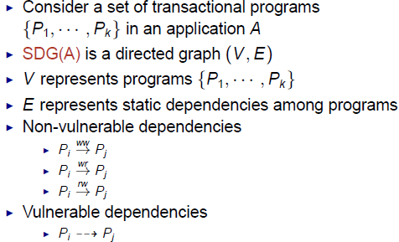

Dangerous Structures

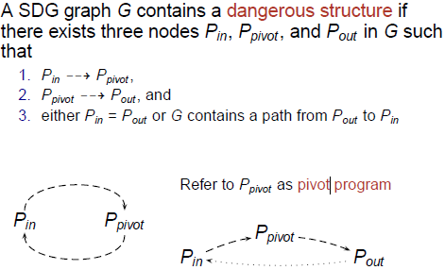

7.9 How to avoid SI anomalies

- Approach 1 : Use a mix of SI and S2PL isolation levels
  - Run the pivot programs using S2PL instead of SI
  - Implementation Details
    - For each object version O_{i} created by a transaction T_{i} under SI
    - O_{i} must be protected by an exclusive lock until T_{i} commits
  - Program Modification Tecgnuqyes
    - Let A be an application with some dangerous structure in SDG(A)
    - For each dangerous structure in SDG(A)
      - Choose one of its vulnerable edges (say (P_{i},P_{j}))
      - Eliminate this vulnerable edge by modifying one or both of P_{i} and P_{j}
    - Make (P_{i},P_{j}) non-vulnerable by forcing the Xact pair execution to become non-concurrent
      - Introduce an extra ww dependency between P_{i} & P_{j}
    - Modification to a program must not change it functionality (can only change its performance)
    - Choosing a minimal set of vulnerable edges to modify to make A serializable under SI is NP-hard.

- Approach 2 : Materialization
  - Let (Pi, Pj) be a vulnerable edge to be modified
    - Pi : SELECT… FROM R WHERE C;
    - Pj : UPDATE R SET … WHERE C;
  - Create a table conflict (id, val)
  - Insert a row (id_{ij}, 0) into conflict to represent the vulnerable edge (P_{i}, P_{j})
  - Add an UPDATE statement to each of P_{i} & P_{j}
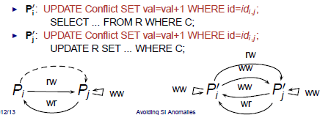

- Approach 3 : Promotion
  - Let (Pi, Pj) be a vulnerable edge to be modified
    - Pi : SELECT… FROM R WHERE C;
    - Pj : UPDATE R SET … WHERE C;

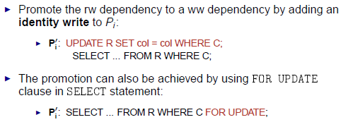

  - Caveat: Not applicable if the rw dependency involves a read that is part of a selection predicate as it could be vulnerable to phantom problem.

